

Lab Experiment – 05
Missionaries and Cannibals Problem

Aim
To solve the Missionaries and Cannibals problem using the State Space Search algorithm.

Objective
To safely transport three missionaries and three cannibals from the left river bank to the right river bank without ever allowing the cannibals to outnumber the missionaries on either bank.

Algorithm
- Start with all missionaries and cannibals on the left bank.
- Place the boat on the left bank.
- Generate all valid boat moves (one or two people).
- Check whether the new state is valid.
- If valid, move the boat to the opposite bank.
- Repeat the process until all missionaries and cannibals reach the right bank.
- Display the sequence of valid states.
- Stop.

FlowChart
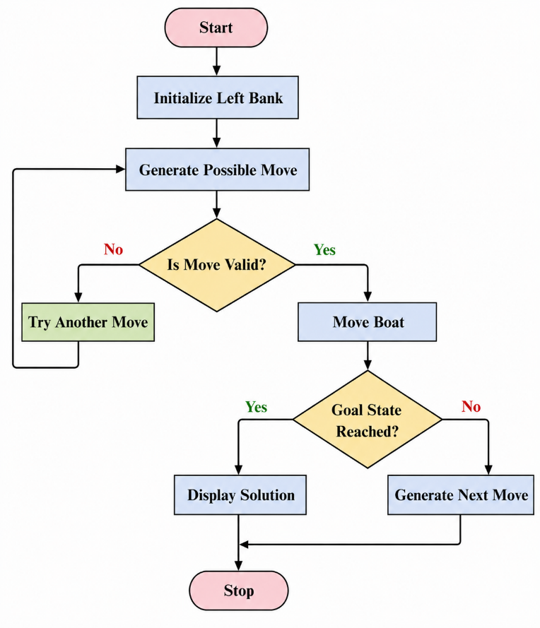
Code:
from collections import deque

def is_valid(m, c):
if m < 0 or c < 0 or m > 3 or c > 3:
return False
if (m > 0 and m < c):
return False
if (3 - m > 0 and (3 - m) < (3 - c)):
return False
return True

def solve():
start = (3, 3, 1)
goal = (0, 0, 0)

queue = deque([(start, [])])
visited = set()

while queue:
state, path = queue.popleft()

if state == goal:
return path + [state]

if state in visited:
continue

visited.add(state)

m, c, boat = state

moves = [(1,0),(2,0),(0,1),(0,2),(1,1)]

for dm, dc in moves:
if boat == 1:
new = (m-dm, c-dc, 0)
else:
new = (m+dm, c+dc, 1)

if is_valid(new[0], new[1]):
queue.append((new, path+[state]))

solution = solve()

for step in solution:
print(step)
Output:
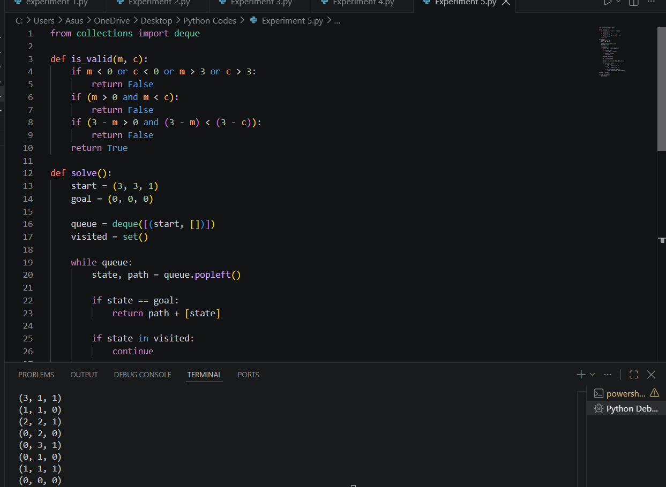

Result
The Missionaries and Cannibals problem was solved successfully using the State Space Search algorithm.

Conclusion
The program successfully finds a valid sequence of moves to transport all missionaries and cannibals safely across the river without violating the problem constraints.

